**Programming Exercise**:

This assignment involves writing several bash script programs.

1. Write a bash script that will input a name and two numbers. Your program should then output as follows:

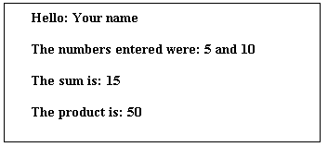

Answer:

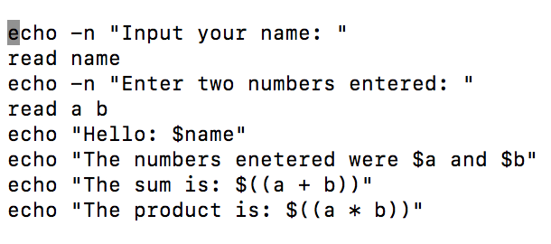

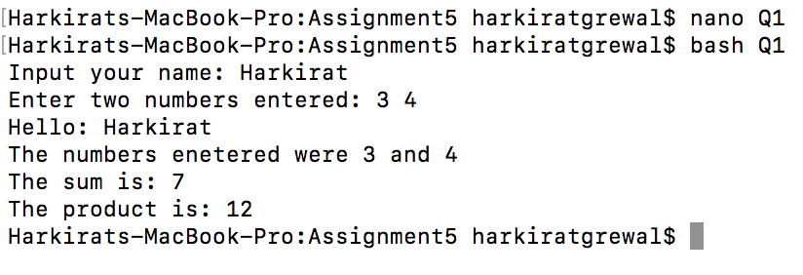

1. Rewrite the above program so your program will continue to execute until the user presses “CTRL/C”

Answer:

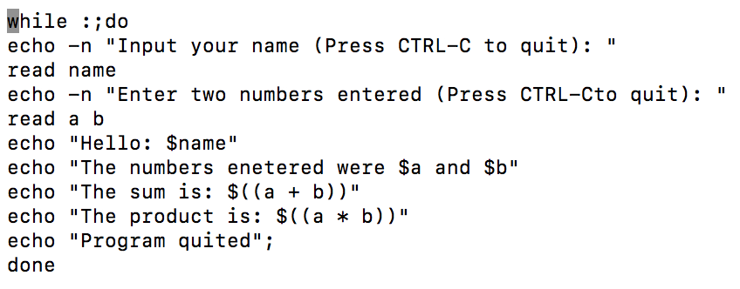

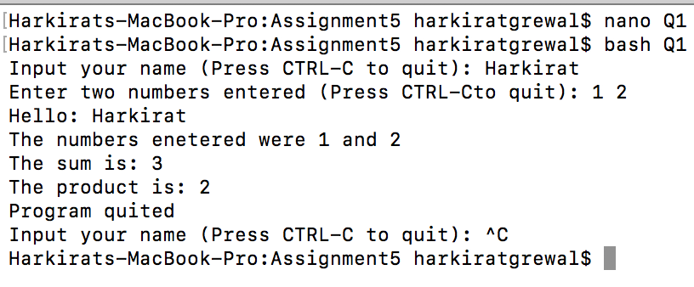

1. Write a program that will input a name and a numeric value between 0 and 100. For each name and number input you program should display the name, grades and letter grade.

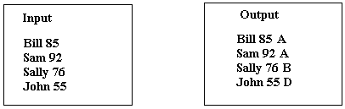

80 - 100 receives an A 70 -79 receive a B

60 – 69 receive a C 50 – 59 receive a D

Answer:

